**Problem Statement:** In the healthcare industry, the challenge is to efficiently manage patient information, appointments, financial transactions, diagnoses, treatments, healthcare providers, insurance, and healthcare facilities while following strict privacy and security rules known as HIPAA (Health Insurance Portability and Accountability Act).

**Key Design Decisions:**

1. Data Security: Implement encryption, access controls, and audit trails within the DBMS to ensure the privacy and security of patient information, adhering to HIPAA requirements.
2. Standardization: Maintain standardized data formats and structures within the DBMS to ensure consistency in medical records and simplify data retrieval.
3. Data Integration: Create relationships and foreign key constraints to establish connections between tables, enabling efficient data retrieval and maintaining data integrity.
4. Data Accessibility: Design user roles and permissions within the DBMS to control access to sensitive patient data, adhering to the principle of least privilege.
5. Data Retention and Disposal: Implement data retention policies within the DBMS to ensure that data is securely disposed of when no longer needed, in line with HIPAA regulations.
6. Performance Optimization: Use indexing and query optimization techniques to ensure the DBMS performs efficiently and provides timely access to patient information.
7. Backup and Recovery: Establish regular backup and disaster recovery procedures to protect patient data from loss or corruption.

**Database Design Decisions:**

Below entities are fundamental to the healthcare system and address key healthcare needs and challenges, including patient care, financial management, and regulatory compliance.

1. Patient Entity: Represents individuals receiving healthcare services, serving as the central point for their medical information and history within the healthcare system.  
2. Appointment Entity: Efficient scheduling is crucial for minimizing patient wait times and ensuring timely access to care.

3. Billing Entity: Managing financial transactions and insurance claims is essential for healthcare facility sustainability.

4. Diagnosis Entity: Accurate diagnoses are fundamental to effective patient care.

5. TreatmentHistory Entity: Maintains records of patient care and health progress for continuity.

6. Doctor Entity: Doctors are key decision-makers in healthcare, responsible for diagnoses and patient care.

7. Treatment Entity: Standardizes medical procedures and protocols for consistency in patient care.

8. CoveragePlan Entity: Details insurance coverage terms, influencing how patients access and pay for medical treatments.

9. InsuranceProvider Entity: Represents organizations that offer insurance plans, facilitating patient access to healthcare services and determining coverage details and costs.

10. Facility Entity: Facilities are the physical locations where healthcare services are provided.

**Entities and Relationships involved:**

1. **Patient:** Represents an individual receiving medical care.

*Relationships*:

A patient can visit multiple doctors, and a doctor can have multiple patients.

A patient can have multiple appointments.

A patient can receive multiple diagnoses.

A patient can have multiple treatment records.

1. **Appointment:** Represents a scheduled medical appointment for a patient

*Relationships:*

Many appointments can belong to one patient.

Many appointments can be with one doctor.

1. **Billing:** Contains information related to billing for medical services provided

*Relationships:*

Many bills can be associated with one patient.

1. **Diagnosis:** Represents medical diagnoses made by doctors for patients.

*Relationships:*

Many diagnoses can be associated with one patient.

Many diagnoses can be made by one doctor.

1. **TreatmentHistory:** Contains records of medical treatments administered to patients.

*Relationships:*

Many treatment records can belong to one patient.

Many treatments can be administered by one doctor.

1. **Doctor:** Represents medical professionals providing care.

*Relationships:*

A doctor can have multiple patients, and a patient can have multiple doctors.

A doctor can have multiple appointments.

A doctor can make multiple diagnoses.

A doctor can administer multiple treatments.

1. **Treatment:** Describes medical treatments or procedures offered by the healthcare facility

*Relationships:*

Many doctors can provide one type of treatment, and a doctor can offer multiple treatments.

1. **CoveragePlan:** Represents insurance coverage plans or policies provided by insurance companies.

*Relationships:*

Many patients can be covered by one coverage plan, and a patient can have coverage under multiple plans.

1. **Insurance Provider:** Represents organizations that offer insurance plans, facilitating patient access to healthcare services and determining coverage details and costs.

*Relationships:*

One insurance provider can offer multiple coverage plans, and one coverage plan can be offered by multiple insurance providers.

1. **Facility:** Represents healthcare facilities or locations where medical services are provided.

*Relationships:*

Each facility can have multiple doctors.

Multiple patients can be associated with a facility.

Multiple appointments can take place at a facility.

ER diagram:

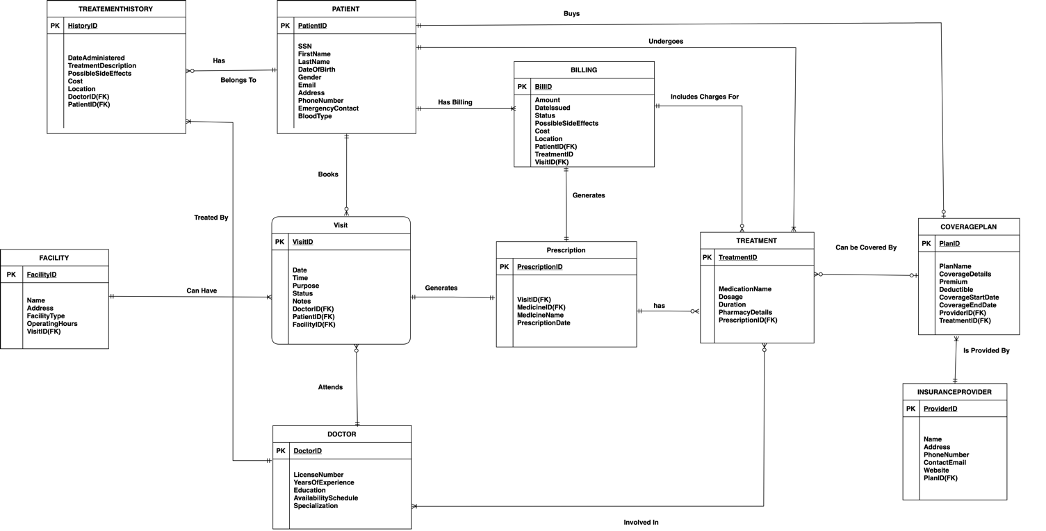  
  
  
  
P3 Changes:  
  
1.

We have replaced the Diagnosis attribute with Prescription Entity.  
  
Prescription Entity:  
Will track prescription record between a Patient and a Doctor, based on the Appointment.  
  
Relationships:  
1 Appointment will generate 1 Prescription.

1 Prescription will generate 1 Billing.

1 prescription may or may not have multiple Treatment.  
  
A "Prescription" entity is better suited than a "Diagnosis" attribute in a Hospital Management System ERD because it allows for more comprehensive and structured data, reflects the patient-doctor relationship, integrates with billing, and accommodates multiple treatments, providing a more detailed and accurate representation of patient care.

2. We have removed the direct link between Doctor and Facility and introduced a ternary relationship which is defined below.

The ternary relationship between Facility, Doctor, and Patient can be defined as "Appointment" where it represents the scheduling of patient appointments with specific doctors at particular medical facilities.

3.We have removed Many to Many cardinalities and made suitable changes accordingly.